AERO 368 Propulsion KNUST

MidTerm Exam March, 2020

Problem 1 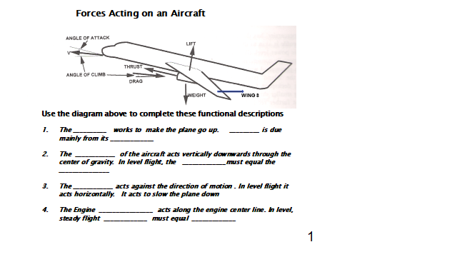Problem 2

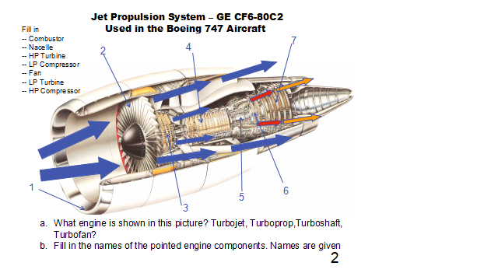

Problem 3

Consider a rocket being launched vertically into space from the surface of the earth. Assume a control volume attached to the rocket, and that the mass within the control volume remains constant. Which of the terms in the integral momentum equation are non-zero.

Σ Fz - aoΣρdv = ∂ ∫∫∫ρuzdv + ∫∫ uz(ρ**u.n**ds)

∂t

1 2 3 4

1. 1, 2, 3, 4
2. 1,2,4
3. 1,2
4. 1
5. None

Problem 4

For this problem evaluate the surface integral ∫∫ **u**(ρ**u.n**ds) for the flow in figure below. **Note**: it is a vector!

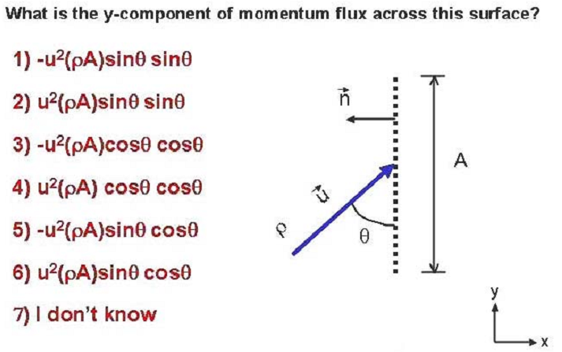

Problem 5

